**Input/output**

Starting the servers in the background and executing the peer1 client.

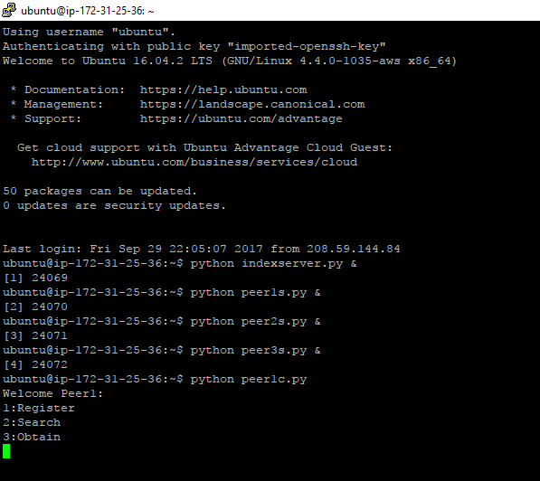

Registering of files from the peer clients (file1.txt has been registered from peer1 and peer2.

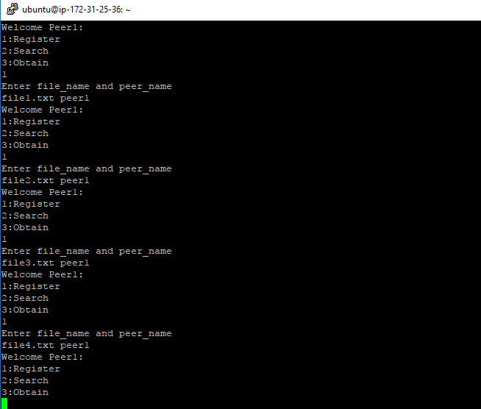

Searching for file1.txt from the peer2 client.

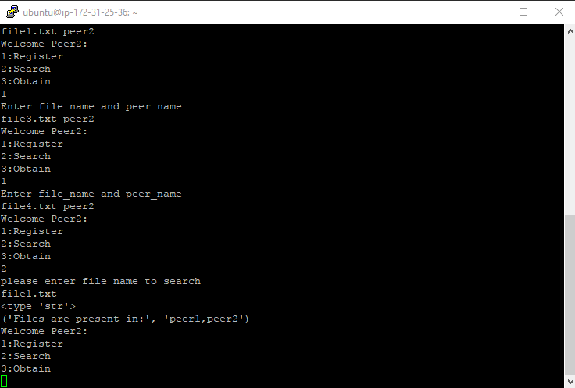

Downloading the file1.txt from peer1 by peer3 client.

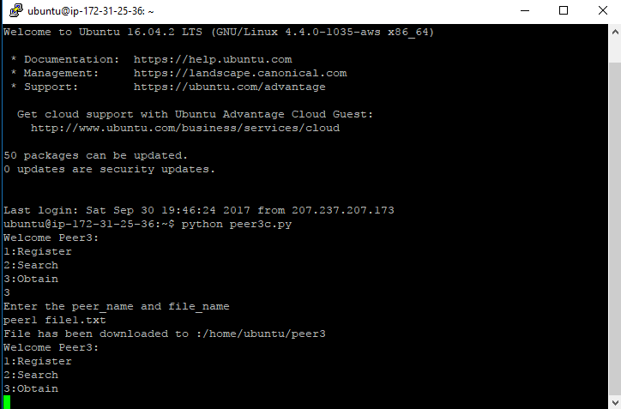

The file is present in peer3.

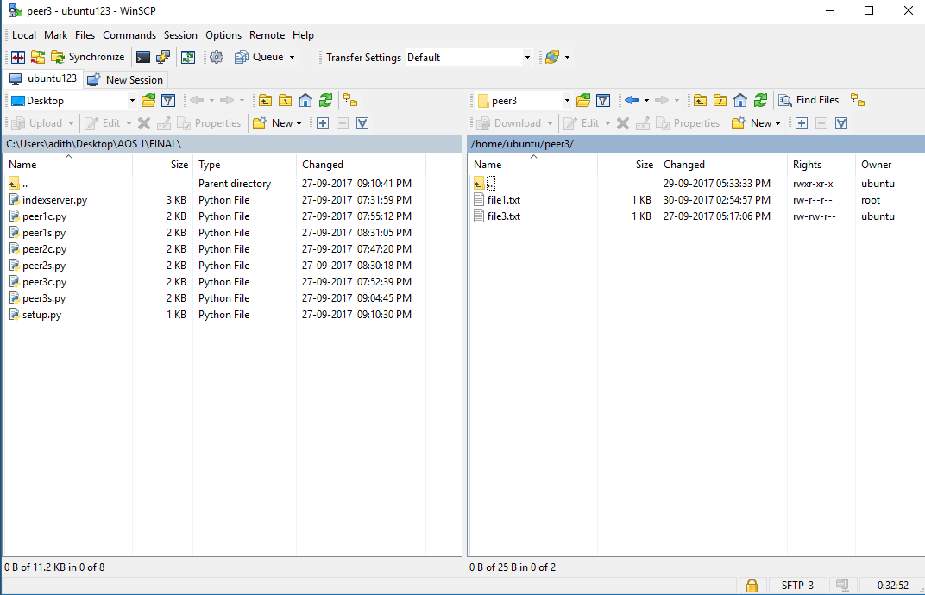

Running all 8 peers:

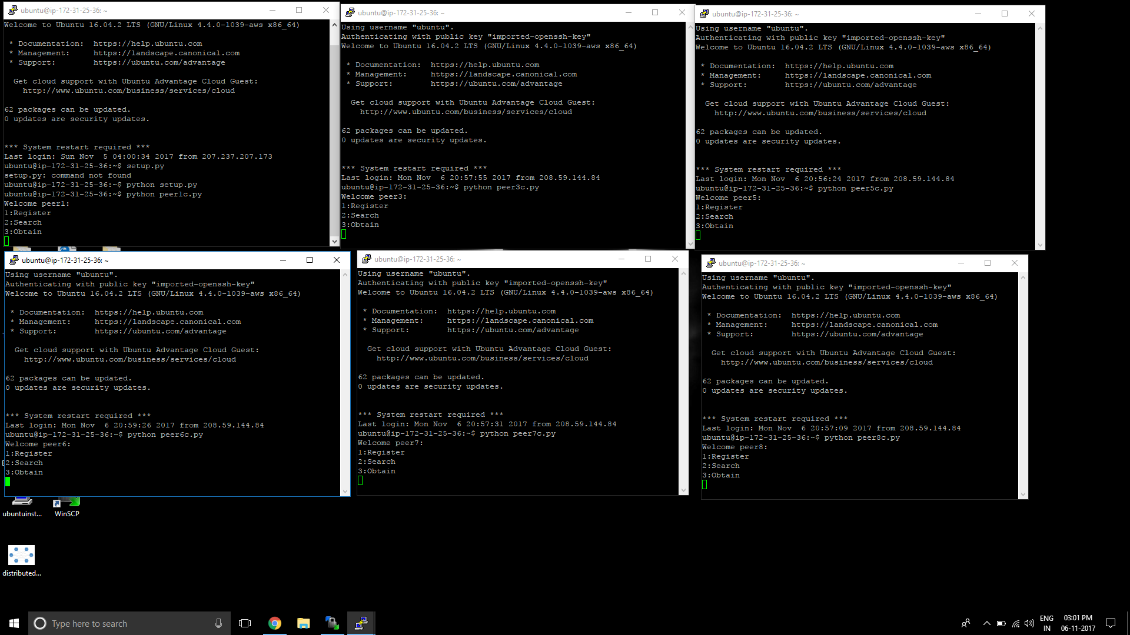

Registering for 8 peers:

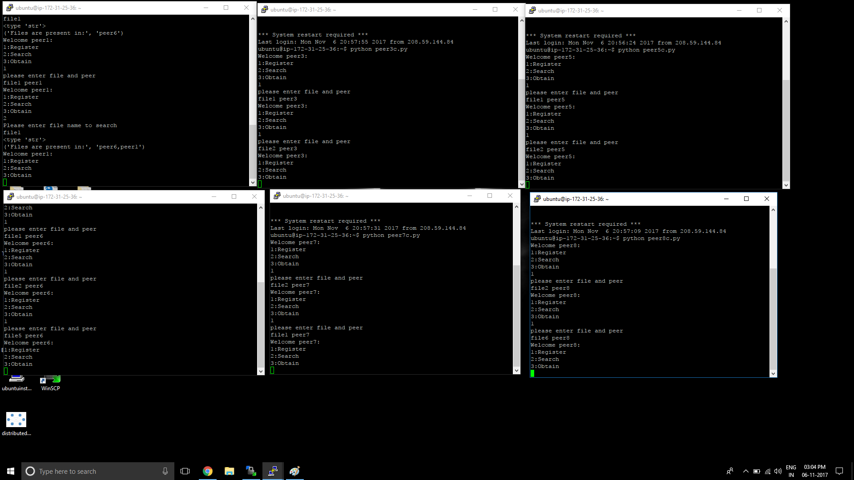

Searching in 8 peers:

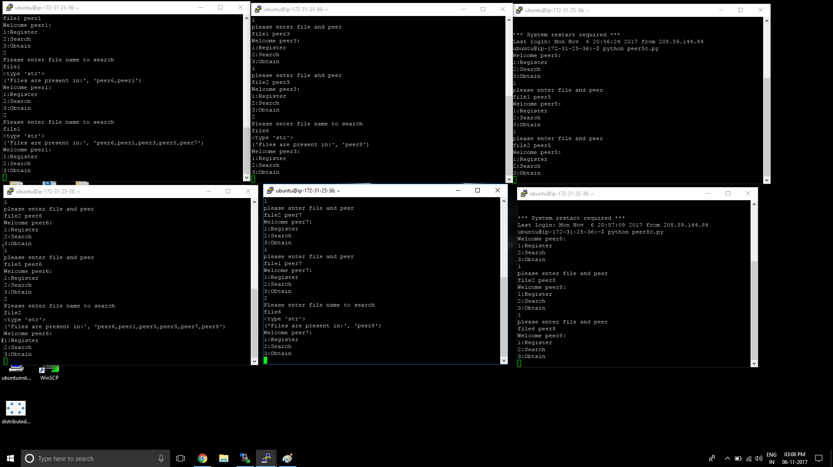

Downloading from peers1,peer7,peer8:

